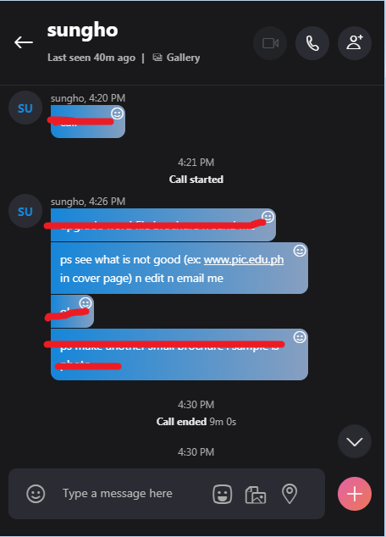

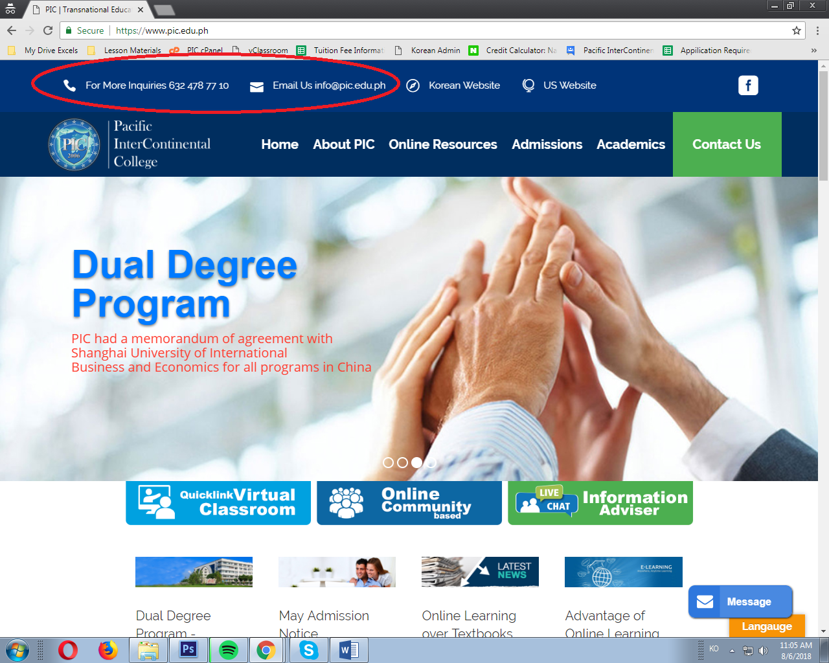

The “For more inquiries & Email us” shouldn’t be at the top header. It should be at the bottom. And the name and logo of the company should be at the top.

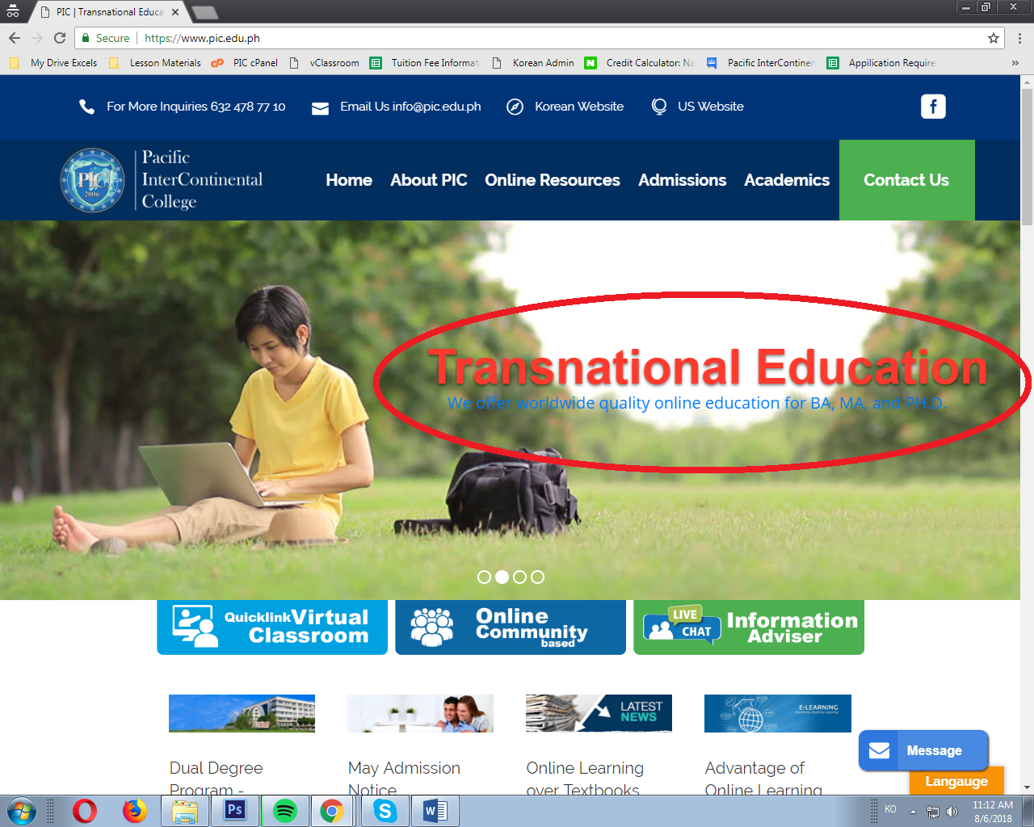

I don’t think red is the ideal font color here. It doesn’t go with the background. Feels like there’s a blood in between the trees. Also, put some box behind the text so it can be read easily.

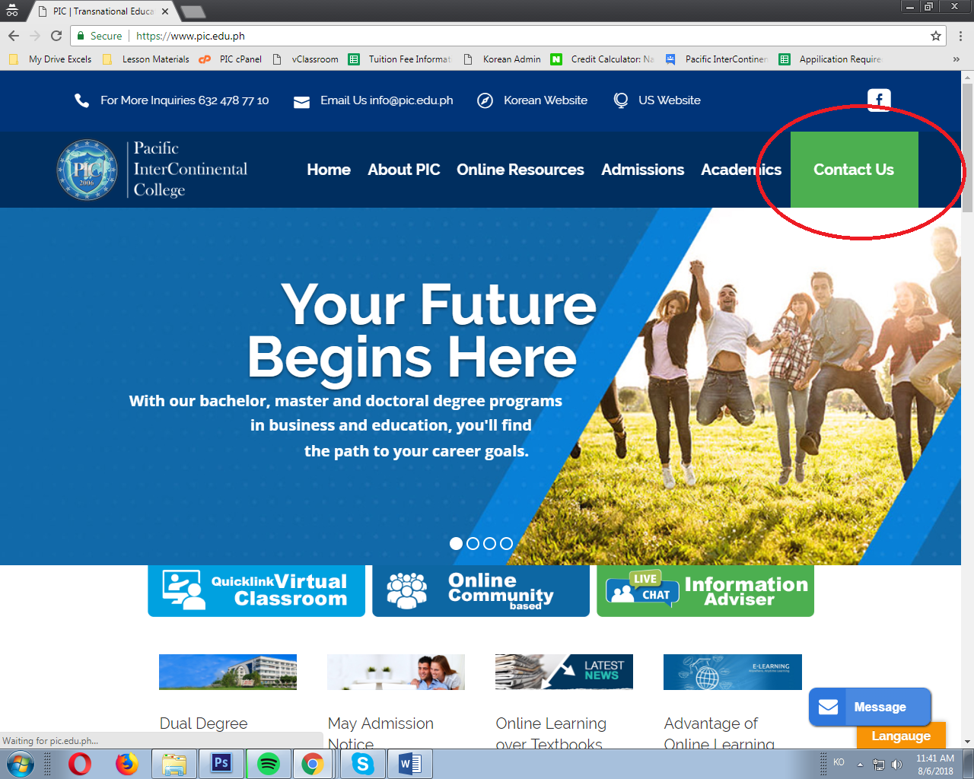

Why is the “Contact Us” green? Is it an accent or what?

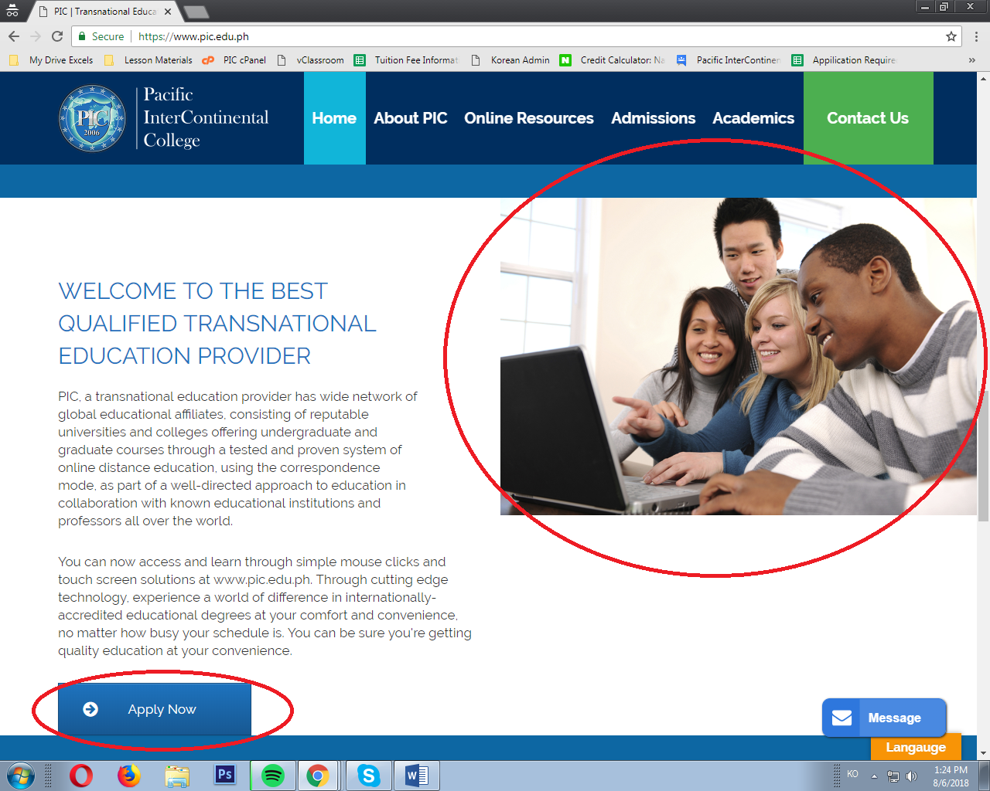

Photo should be centered. The “Apply Now” button should move a bit up. It’s overlapping.

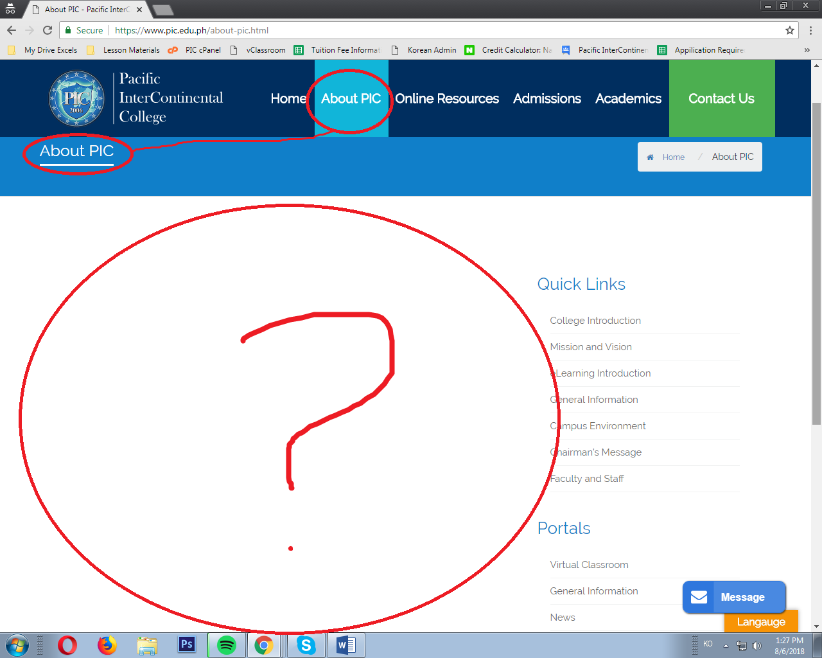

The “About PIC” button from the menu doesn’t have any content. I think this page is where the company’s history can be read. Like when did the company start, who’s the founder, etc.

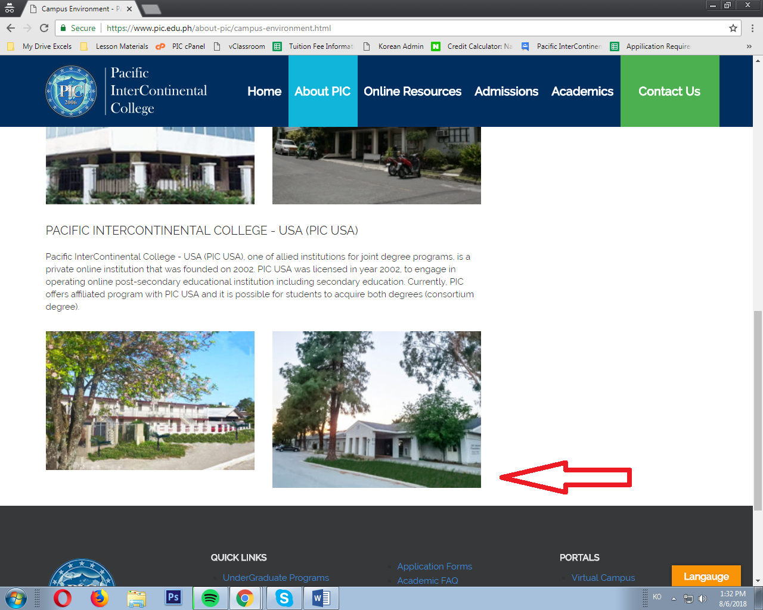

Resize the photo. It should be aligned with the photo beside it.

Also, all the paragraph should be written in 3rd POV.

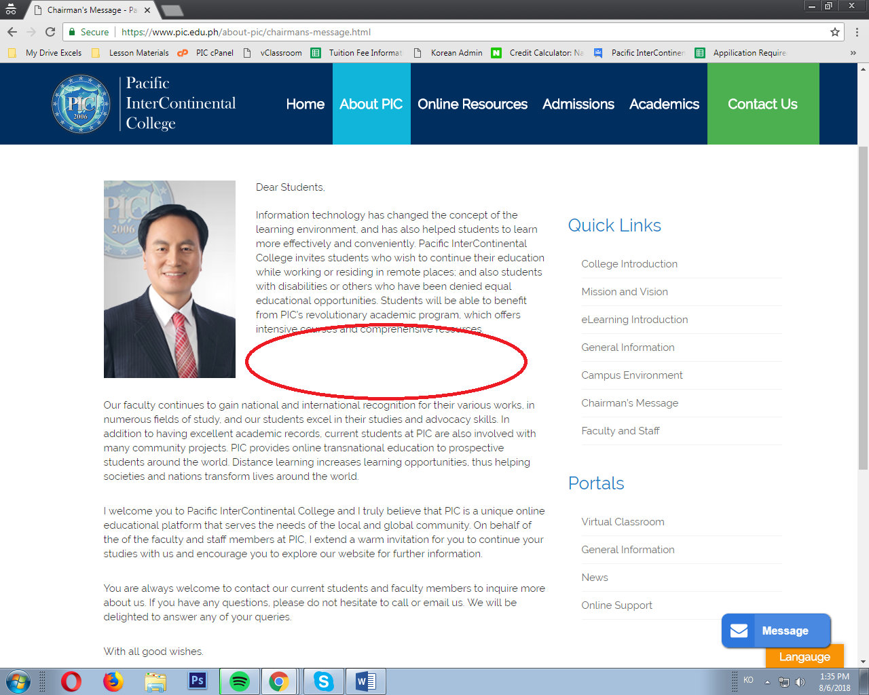

Too many spaces.

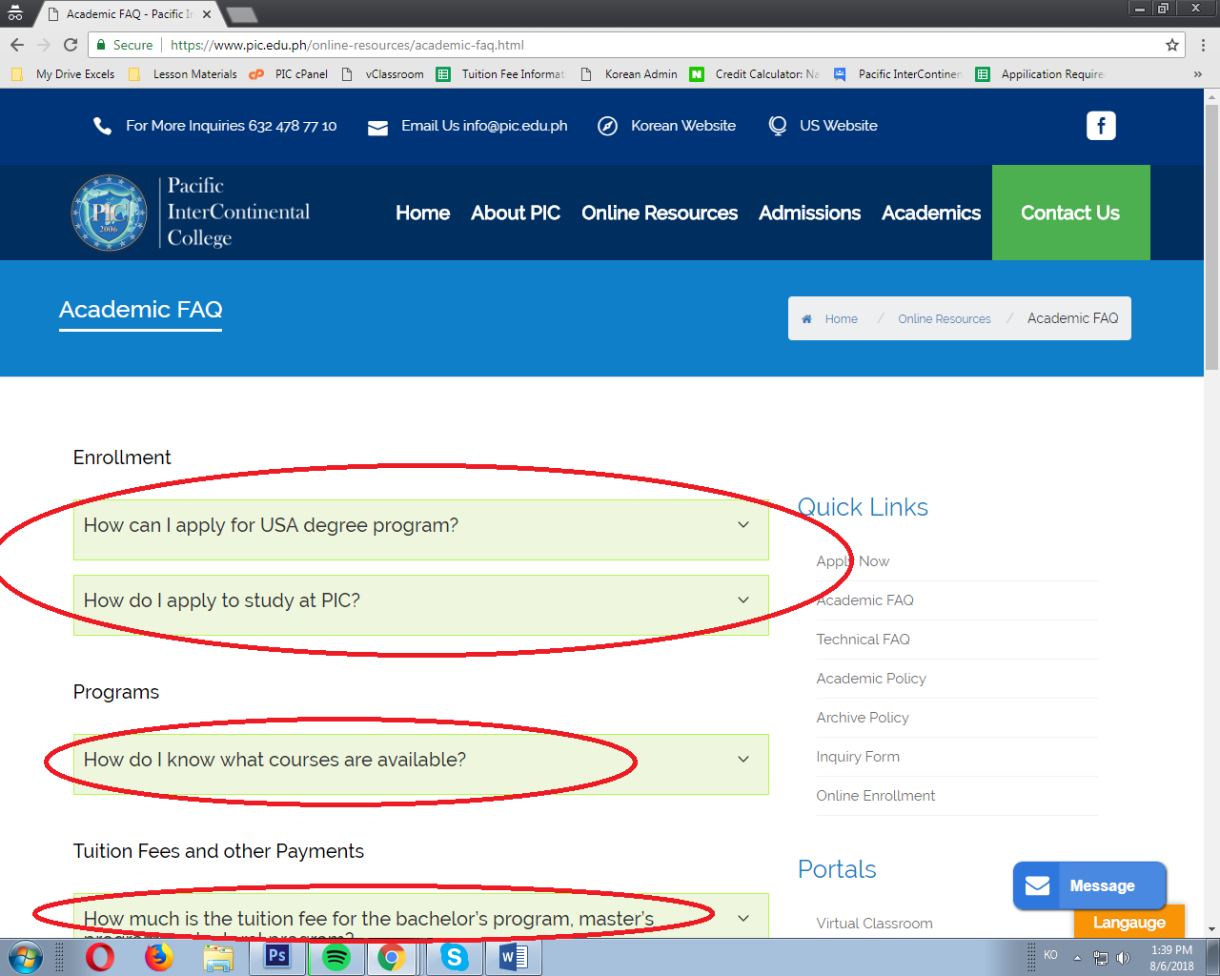

Do not bold the part under the subjects like “Enrollment”, “Programs”, etc.

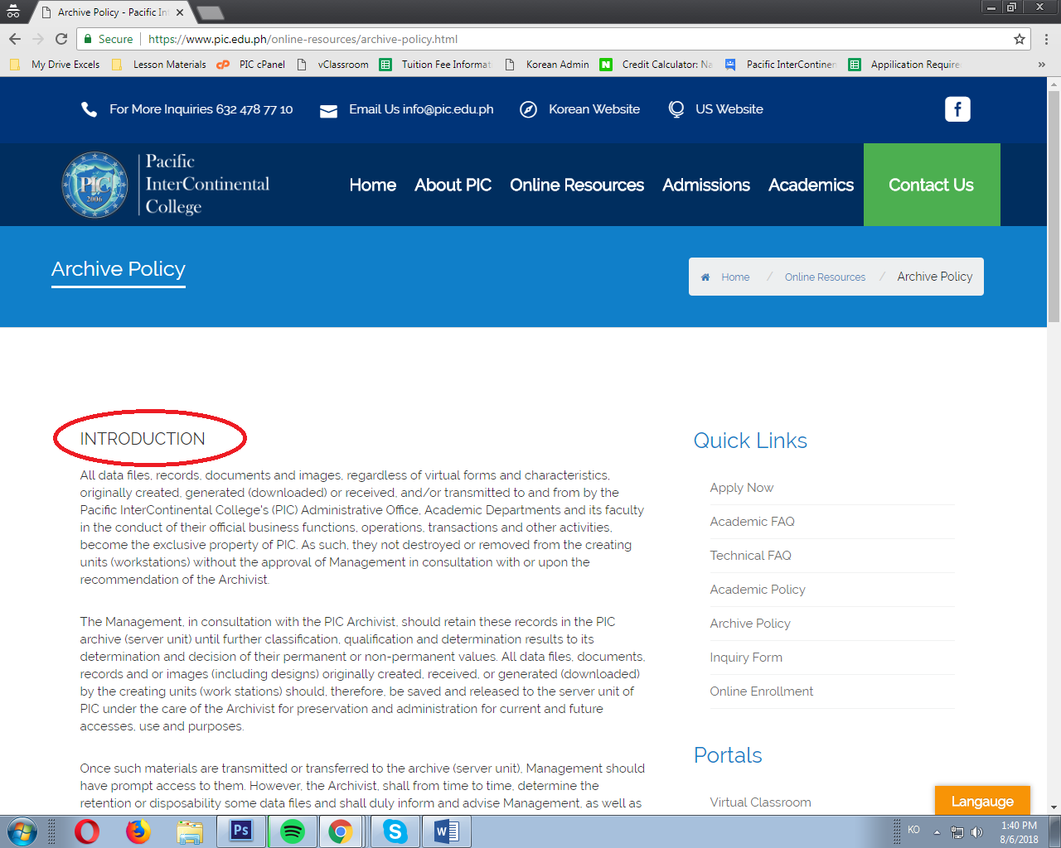

Bold the subjects like “Introduction”.

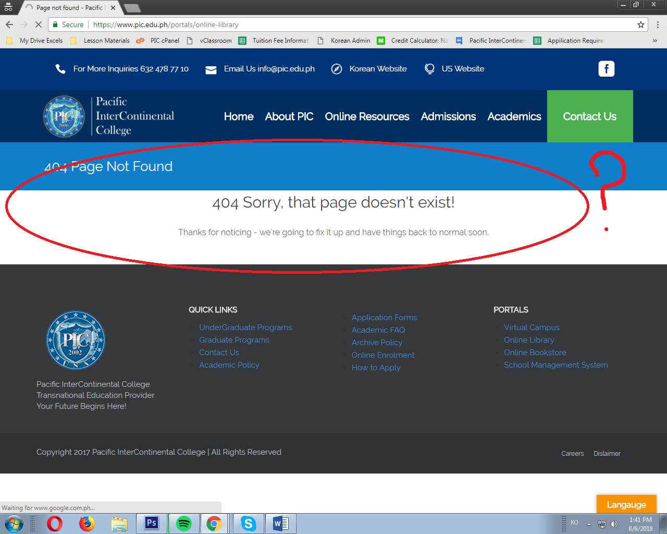

This is under the Online Resources/Portals/Online Library.

Put content or else remove the Online Library button. As well as the online bookstore.

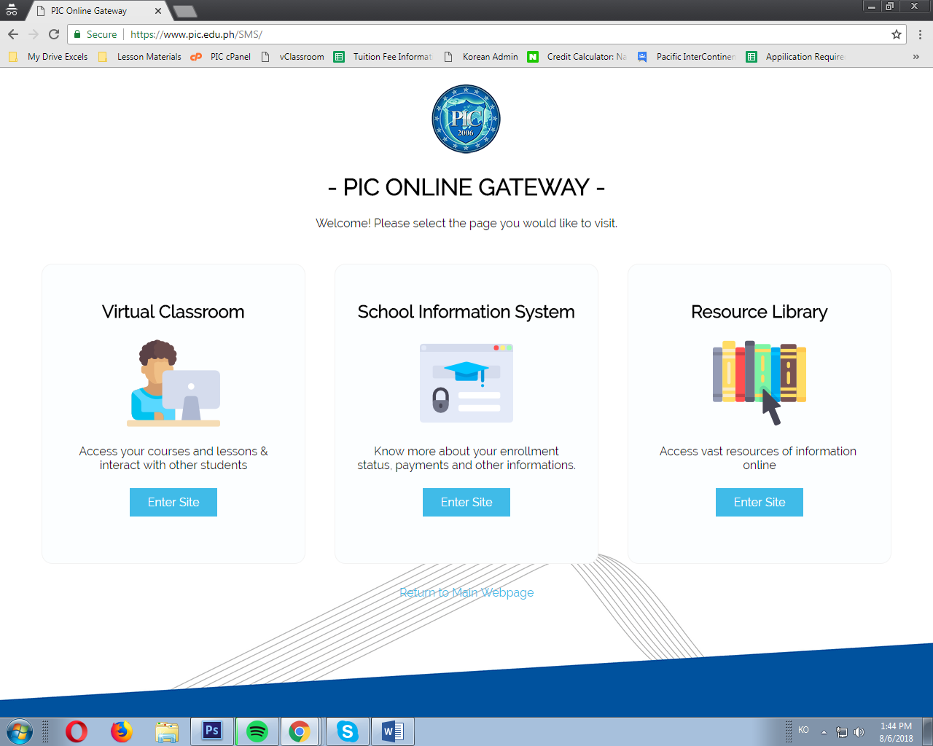

The “Virtual Campus” Button is the same with the “School Management System”. Very redundant.

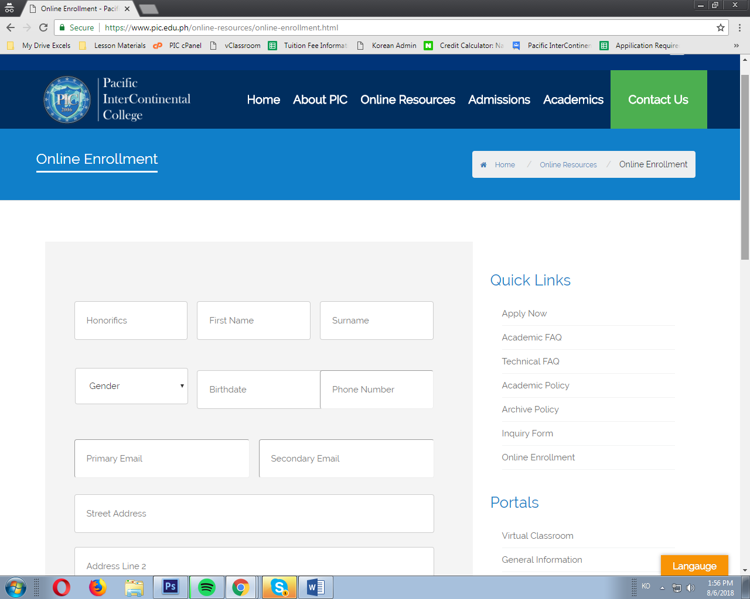

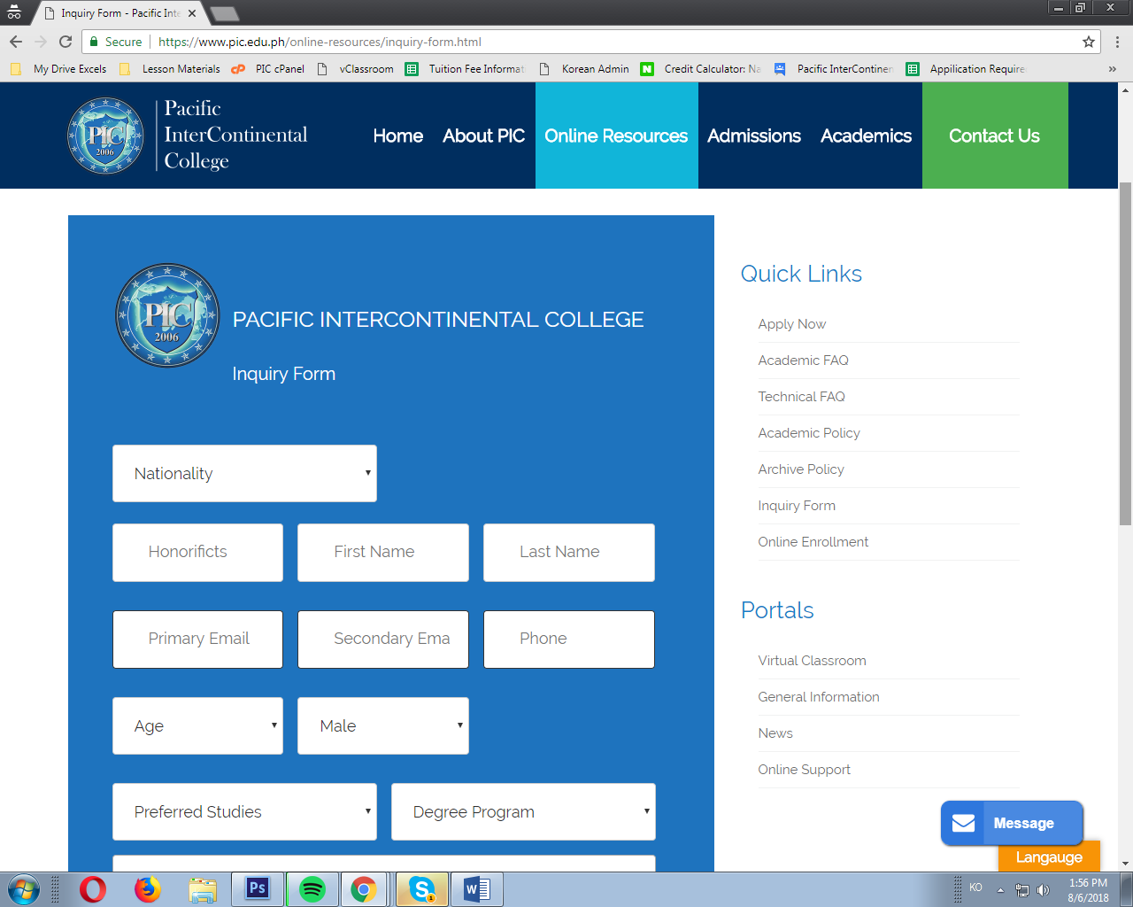

Make the background with the same color. Consistency.

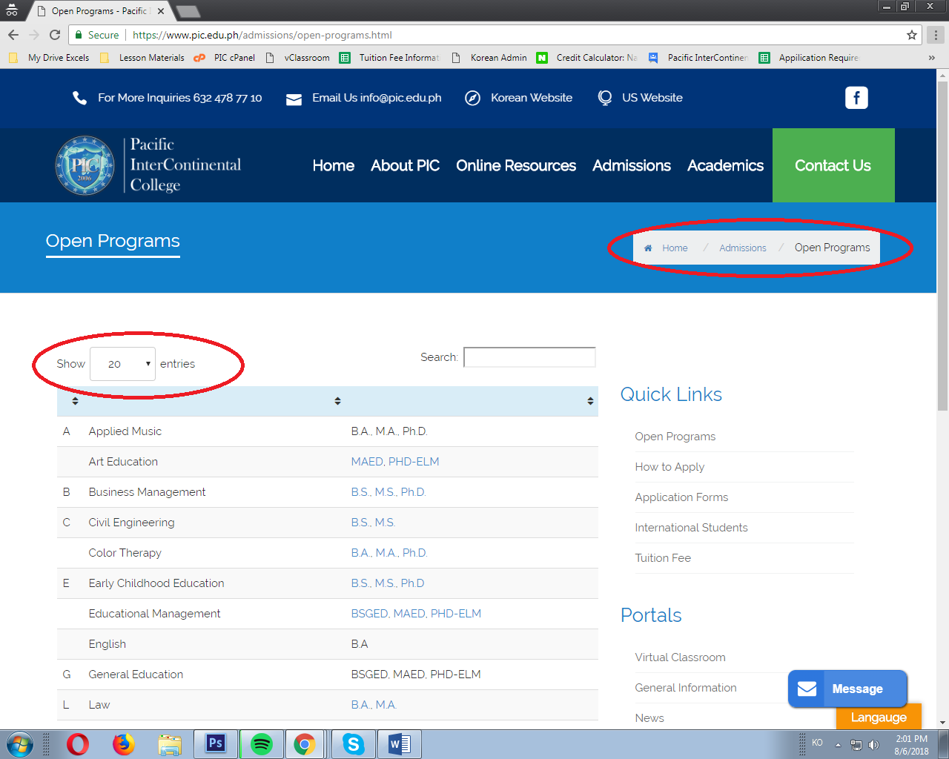

What’s the purpose of the “Next” and “Previous” button (can be seen below of the actual site) when it’s not even clickable? And what is also the purpose of the “Show 20 Entries” dropdown button when the content only have “18 Entries”? Remove the home/admission/open programs above. Very redundant.

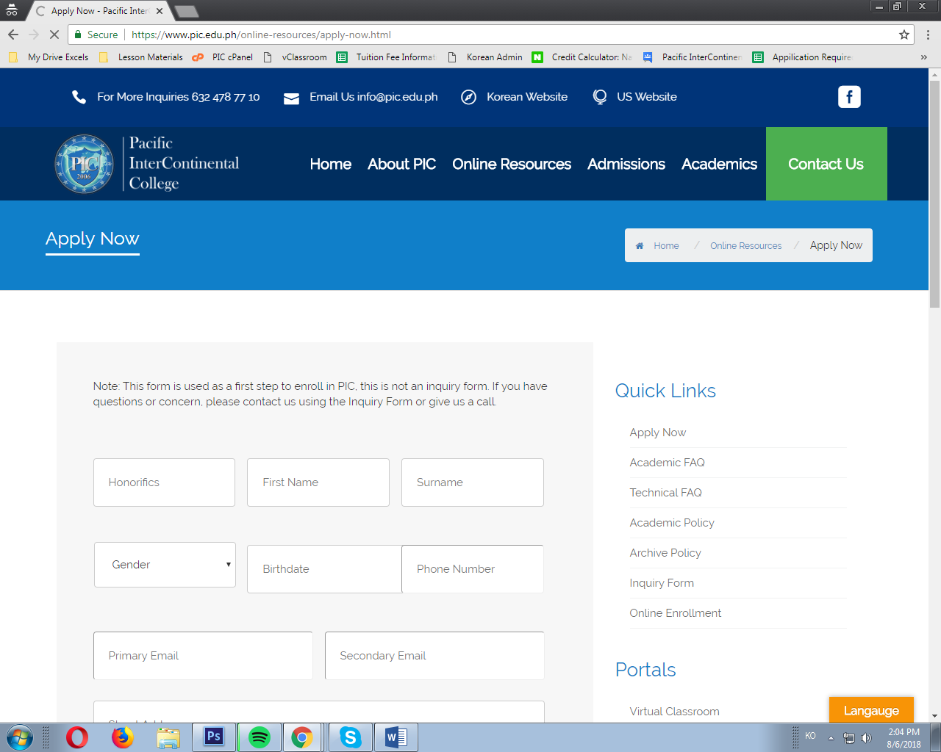

What is the difference between the “Online Enrollment Form” and “Apply now” form from the Admissions? I believe that it’s the same, so why put another for the same content? Why not make it one?

Also, redundancy with the “Application Form” from “Online Resources” and “Admission’s” “Application Form”.

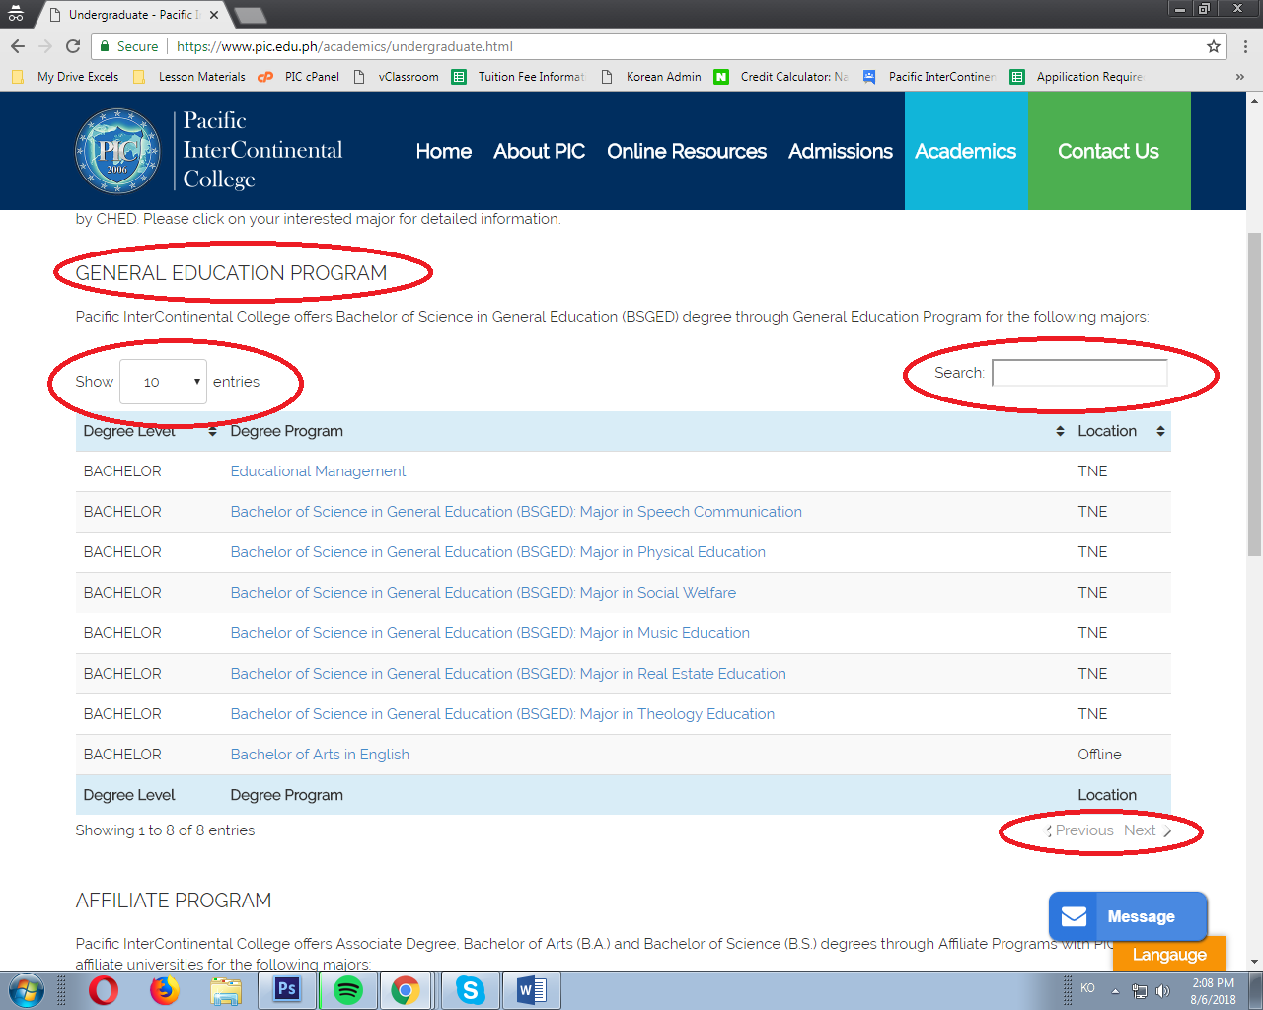

Bold the subjects like “Undergraduate Program”, “General Education Program”, etc.

This also has the “Previous” and “Next” button (I don’t get the purpose when it’s not even clickable).

Don’t put the dropdown box if the content is less than 50—this opinion is also applicable in “Academics/Academic Major”